**Planning, Managing and Monitoring Communication**

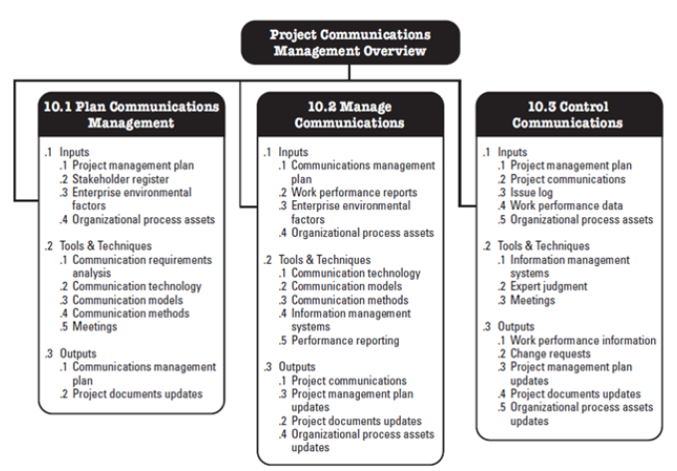

***Figure 1: Plan, Managing and Monitoring DIIT Communications***

**Plan Communications Management** deals with the **Variance** in messages, communication methods and targets requires thoughtful **Planning**.

* Plan for internal and external **Project Communications**.
* Develop a strategy for communicating with all **Key Stakeholders**.
* Determine what **Organizational Assets** will be useful in communicating.

The **Manage Communications** process handles all tasks related to active communication including creation, collection, distribution, storage and retrieval of **Project Communications** in all its forms.

The **Monitor Communications** process monitors, controls communications from beginning of project to end, ensuring information is properly disseminated to **Stakeholders**.

**Internal Communications**

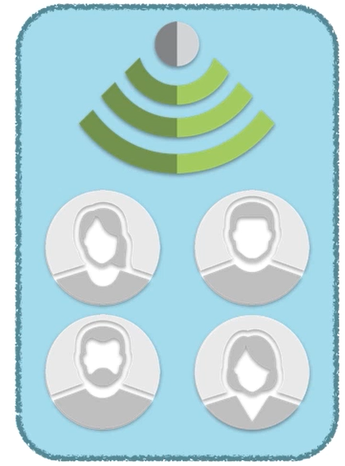

***Figure 4: Internal Communication***

**Internal Communication** occurs when communicating information with the **Project Team**.

* May include all team members, a subset, or an individual.
* Includes key **Stakeholders** not actively engaged in **Project Work**.

**External Communication**



***Figure 4: External Communication***

**External Communication** is where the **Project Manager** represents the team when speaking with others such as:

* **Customers.**
* **Vendors**.
* Other **Project Teams**.
* **Third Party** organizations.
* Public at large.

**Various Communication Types**

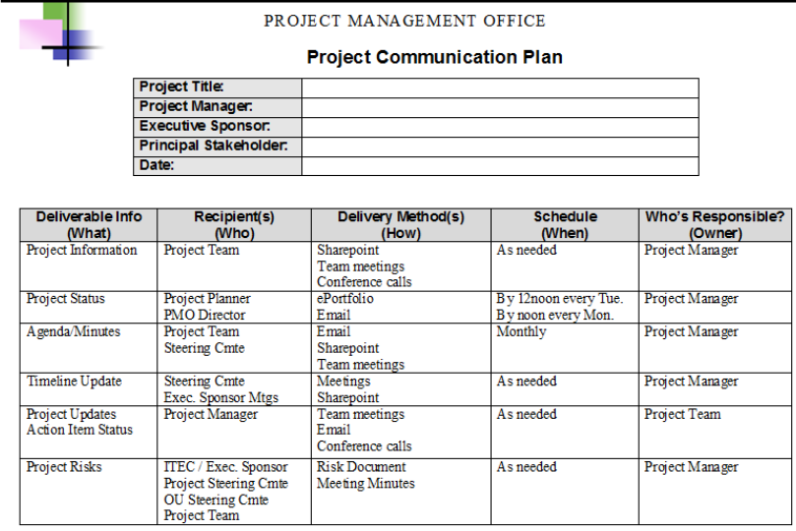

***Figure 5: Sample Communications Plan***

**The Division of Instructional and information Technology (DIIT) Project Management Office (PMO)** will to leverage these various **Communication Types** when conducting daily operations:

**Formal Communication** is presented with a high level of professionalism after significant preparation.

* **Reports.**
* **Meeting Minutes**.
* **Briefings & Status Presentations**.

**Informal Communication** is typically conducted in the flow of **Project Work**. More spontaneous and less deliberate than formal methods:

* **Emails.**
* **Memoranda.**
* Water cooler discussions.

**Vertical Communication** includes instances of communicating with superiors or subordinates, often including **Requests**, **Status Reports** and **Directives**.

**Horizontal Communication** includes instances of communicating with organizational/project peers, often including discussions regarding project technical and conceptual details, instances of **Expert Judgment**.

**Official Communication** is treated as a matter of fact or representation of actual position.

* Quarterly and annual **Reports**.
* Published **Releases**.

**Unofficial Communication**

* Off-the-record Accounts.
* Hypothetical Scenarios.
* Drafts of future official communications.

**Communication Formats**

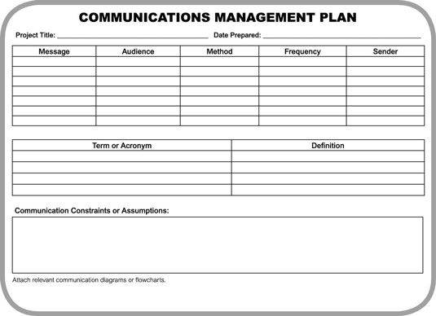

***Figure 6: Blank Communications Management Plan***

**Communication Formats** may be written or oral, and the nonverbal body language also sends messages when communicating. The subtleties of verbal communications should be kept in mind. Especially true when cultural differences exist.

**Active Listening** involves understanding in order to be understood by:

* Being mindful of subtleties in communication, differences in style.
* Searching for underlying meaning.
* Asking questions to clarify as needed.

It is important to inquire and probe to verify you comprehend information with Questions to:

* Verify others comprehend information with questions.
* Trigger new lines of thought with insightful questions.

Education conveys new information and skills to team members and

* Increases team effectiveness by increasing **Team Knowledge**.
* Undertakes fact finding tasks to learn and confirm Information.

**Expectation Management** sets a bar for Team Member accomplishments.

* Manage expectations of **Stakeholders**.
* Separate expectations of **Team Members** and others as needed.

Persuasion induces **Team Members** to accomplish **Project Work** by coaxing **Stakeholders** to provide necessary **Project Resources**.

* Enticing valuable parties to contribute to the **Project**.

Motivation & Coaching improves **Team Member** morale and team performance by effectively convey value of **Work** and **Project Outcomes**.

**Negotiation** successfully satisfy **Project Needs** while respecting **Project Limits** by striking deals acceptable to **Project Team**, organization and counterparty.

**Conflict Resolution** prevent by challenges from impacting **Project Work**.

* Listen actively to understand grievances, persuade parties to agree to a resolution.

**Summarization & Road Mapping**

* Convey important details to others quickly and succinctly.
* Describe next steps and work remaining on project.

**Types of Communication**

* Internal.
* External.
* Formal Informal.
* Vertical.
* Horizontal.
* Official.
* Unofficial.

**Formats of Communication**

* Written or Oral?
* Cultural Differences.
* Nonverbal Signals.

**Communication Skills & Circumstances**

* Active Listening.
* Inquire & Probe.
* Education.
* Manage Expectations.
* Persuasion.
* Motivate/Coach.
* Negotiation.
* Conflict Resolution.
* Summarization.
* Road Mapping.